# PERFORMANCE AND ENERGY EFFICIENT ROUTING PROTOCOL FOR SENSOR NETWORKS

##### **\*Ritesh Matale1, Bhushan Chaudhari2, Rajeev Patil3**

*1Student,Computer Engg., SKNCOE, Pune, India -411041.*

*2Student,Computer Engg., SKNCOE, Pune, India -411041.*

*3 Student,Computer Engg., SKNCOE, Pune, India -411041.*

*1Email Id: riteshmatale7@gmail.om*

*2Email Id: bhushan4235@gmail.com*

*3Email Id: rajeevvpatil@gmail.com*

**Abstract:** In wireless sensor networks, a wide range of protocols exist for data transmission. Most of these protocols prove inefficient when a large number of nodes have to be handled. Geographic routing protocols prove useful in this case, among which greedy forwarding is the most efficient. In greedy forwarding, the next hop is selected by considering the node closest to the destination node. This selection process may affect the energy efficiency of the overall network by using the same paths over and over thus drowning battery of the nodes in that path. Void creation is another problem generated by this protocol. We have studied, evaluated and compared existing protocols and have tried to develop our own that finds the proper balance between performance and energy efficiency of a sensor network.

Keywords: Topology, energy, embedding, sensor networks, routing protocol

**Introduction**

# The focus is principally on a large vary of protocols that are worked on wireless sensing element networks. Among these are them that rely on geographic location of the nodes and therefore the protocol functioning on them is known as a geographic routing protocol and therefore the methodology that's a lot of economical during this is greedy forwarding. This is often terribly effective in matters of reducing delay and in terms of performance. The utilization of this methodology is wide advantageous once the nodes are in sizable amount perhaps thousands. The states are reduced as there's the reduction of storing the data of all nodes with every and each alternative node within the network which is why the delay is been reduced. however blessings of greedy forwarding escort some limitations. These are that at some purpose within the method the tactic stops operating effectively as per needed as a result of the physical distance data of the nodes tend to be merge for causation packets on some ways. In order that they got to once more generate packet request method and begin the looking of another path once more. This is often time overwhelming and inefficient and that they generate holes within the network from wherever the packets are unable to send and causation might face shortage of power. This is often thanks to the improper and inaccurate data regarding the topology of the network unbroken with all the nodes. This topology inconvenience tends to hamper the performance of forwarding packets with efficiency. The need of long period of time of the nodes and therefore the network is additionally essential half. Notwithstanding the GF methodology reduces the hop count, a specific node within the path when your time might face shortage of power and generate gap. This can divide the network and increase the retransmissions and hamper the causation method. The on top of observations have impelled to implement a new protocol which will boost the performance in addition as energy potency of the GF methodology in sensing element networks. This new thought brings along the necessities of getting a network with correct topology data and remaining energy data of the nodes within the entire network. additionally the cupboard space needed will be reduced to store this data by scaling methodology and therefore the process are going to be quicker. this is often achieved by dividing the network into sections and assignment section heads for grouping these data regarding nodes and additionally assignment coordinates to them that are scaled to low dimensions.

# Literature survey

## Shortest Path First

In this approach a classical technique is employed within which a distributed variety of Dijsktras rule is employed to compute the shortest path between the supply and destination. The protocols square measure Distance Vector and Link State within which the shortest path between all supply to destination pairs is maintained. Also every node within the network must store succeeding hop to its destination. Therefore for a network with n nodes will end up in n2 messages to be changed and n range of states to be hold on at each node. This overhead scales poorly to large networks.

## Greedy Perimeter Stateless Routing Protocol

Greedy Perimeter homeless Routing Protocol (GPSR) may be a novel routing protocol that uses positions of routers and packet and destination to form forwarding selections. It uses greedy forwarding strategy to pick subsequent hop that's nearest to the destination. If the greedy forwarding fails then the algorithm recovers by routing round the perimeter region. The algorithmic program uses right hand rule for tracing its perimeter. The overhead of enormous range of states is reduced during this algorithm however this algorithm doesn't provide global optimum.

## Cross Link Detection Protocol

Cross Link Detection Protocol is an corrected version of all previous protocols that rely upon the belief regarding radios and resulting connected graphs. But it's tested that these perfect assumptions are desecrated by real radios and will cause failures in routing. These are fixed by CLDP that allows correct geographic routing. This protocol produces a subgraph on that discretional face traversals doesn't cause a routing failure despite radio irregularities and localization errors algorithm doesn't offer world optimum.

## Logical Coordinate Routing

Logical Coordinate Routing(LCR) constructs coordinates of nodes supported some landmarks. based on these coordinates a distance function is formed and routing is performed to reduce this function. once greedy routing fails then the algorithm backtracks the packet on the trail till an acceptable path is found.

## Beacon Vector Routing

Beacon Vector Routing is the technique for point-to-point routing in wireless sensor networks. It assigns coordinates to the nodes based on the hop distance o explicit nodes referred to as beacons then constructs a distance metric on these coordinates and then it incorporates the greedy forwarding strategy to send packets to the consecutive hop that's nearest to the destination.

# Working model:



Fig 1:Architecture

The working architecture of the protocol is shown above. The figure above illustrates the use of greedy forwarding protocol to send data packets from the source node to the destination node . The nodes that gather information are termed as section heads or anchor nodes which divide the network into sections. The distances from the node with each other needs to be maintained and updated to attain accurate connectivity information. This will eventually increase the size of the states in terms of their dimensions.

1. Sections heads/ Anchor nodes:

The selection of section heads is done by centroid method. This ensures the uniform distribution of the sections throughout the network. The information of these section head is first collected by the base station. This information proves useful while sending data packets. These nodes maintain the distance information of all the other nodes in it's range. The information is then scaled by using Multidimensional scaling method which minimizes the memory required to be store it.

## Scaling and assigning coordinates:

Scaling is advantageous to reduce the size of coordinates. It reduces the storage space required for the states. It simplifies the network by converting the coordinates of a node to low dimensional Euclidian space.

After scaling is done, the scaled coordinates are assigned to the nodes which are there in the range of checkpoint nodes. These node distance information is more flexible and error tolerant as it is based on the virtual hop distance and not on the real physical distance.

## Energy constraint

## Always selecting the quickest path is not enough to ensure the proper functioning of the network. The shortest path selection will use the same nodes over and over thus resulting in the depletion of the energy of those nodes. To prevent this an energy constraint is applied. A threshold energy is applied to all the nodes. When the node energy goes down to the threshold energy, an alternate path is selected to prevent that node from dying.

**Mathematical Model**

The mathematics associated with our protocol has, mainly the Multidimensional scaling model (MDS) which is the standard technique to reduce dimensionality of the data that is given as an input to it.

The input to this method will be a n dimensional vector of distance of a node to all others in network. Suppose

di = [di1,di2, di3 ....din]

where di is vector of ith node and dij is distance in hop from node i to j.

This is n dimensional input to the MDS. Classical scaling is one method of MDS where the dissimilarities are directly treated as Euclidean distance between the points

plotted in space. The n dimensional vector will be then converted to d dimension

where d¡¡n through this scaling. Thus the vector will be

di = [di1,di2,di3....did] where d << n

This scaling is done for preserving the actual distance of nodes in the network.

Then the scaled coordinates are been assigned to the nodes and using these coordinates Euclidean distance will be calculated between the nodes which is given by,

if node p is having coordinates (p1, p2) and node q is having coordinate (q1, q2) then,

dist(p,q) =∑2 i=1 √(pi  - qi)2 .............(i)

Based on this distance formula the node from the neighbor which is nearer to destination will be calculated. And the distance of the entire path will be the summation of equation ( I ). And the energy of a node in the path will be calculated as,

Er = Emax - (et +er)..........................(ii)

where,

Er is remaining energy of a node

Emax is initial energy of a node

And (et + er) is the energy consumed, where et is energy during the transmission and er is the energy during reception. The entire paths of energy will be the summation of equation(ii) for all nodes in the selected path.

Therefore the entire paths metric will be as by combining equation (i) and (ii) as

Path(x1,xn) = min(dist(xi, xn))+max(Er (xi,xn)).......(iii)

Where,

x1 is 1st node in the path and xn is nth node in the path.

The equation(iii) is final weight of the path to be selected for the transmission.

.

**Algorithm**

Step 1: Select the section heads using centroid method. Suppose selected are n nodes from total N nodes.

Step 2: Calculate the distances of all the nodes in the area of these n nodes.

*Di* = {*di*1*, di*2*, ....., dil*}

*Erm* = {energy (m)} where m=1, 2, ..., N.

where i = 1,2,…,n and di,l is distance of node l to n nodes. collect these distance metric at these n node.

Step 3: Scaling is to be performed on these distance vectors to reduce the storage space of states into n dimensions where n<<N total number of nodes as per MDS.

Step 4: Source sends the path request message and selects the path as per the Greedy Forward method.

Step 5: If the nodes in the path are been getting depleted by energy ,then check for the alternative path with maximum energy nodes and choose another node for sending data.

Step 6: Send packet to the next selected node.

Step 7: do this until all packets are been sent within given time and then stop.

**Data flow diagram**

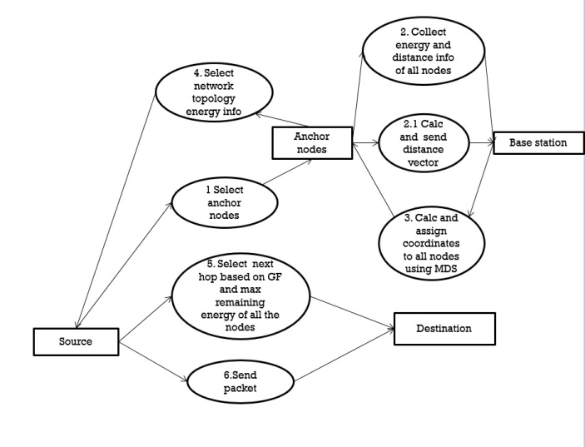

Fig 2. Data flow diagram

**Conclusion:**

In this paper, we have tried to develop a routing protocol that overcomes the limitations of previous protocols regarding geographic routing in sensor networks. Also the universal problem of energy efficiency is addressed. Previous methods like greedy forwarding is improved by gathering accurate global information about the location of each node in the network. To achieve this, we have added more features to it such as maximum energy path, multidimensional scaling etc. This will reduce required storage space by assigning scaled coordinates to each node. The life of the network is increased by selecting maximum energy path. This increases lifetime and usability of sensor nodes in remote locations resulting in performance enhancement of the overall network.

**References**:

1. Eason, B. Pei Huang, Chen Wang, and Li Xiao, Improving End-to-End Routing performance of Greedy Forwarding in Sensor networks , IEEE 2012 Transactions on Parallel and Distributed Systems.
2. Bighnaraj Panigrahi, Swades De, Bhawani Sankar Panda, Jean-Daniel Lan Sun Luk, Energy Efficient Greedy Forwarding Protocol for Wireless Sensor Networks , 3rd ed. 2010 IEEE.
3. Shraddha P. Dugam, S. P. Pingat, ”An Overview of a Method for Increasing Performance and Energy Efficiency of Geographic Routing Protocol in Sensor Networks”, 2013 International Journal of Computer Applications (0975 8887)
4. Shradha P. Dugam, S. P. Pingat, ”An Overview of a Method for Increasing Performance and Energy Efficiency of Geographic Routing Protocol in Sensor Networks”,2013 International Journal of Computer Applications (0975 8887)